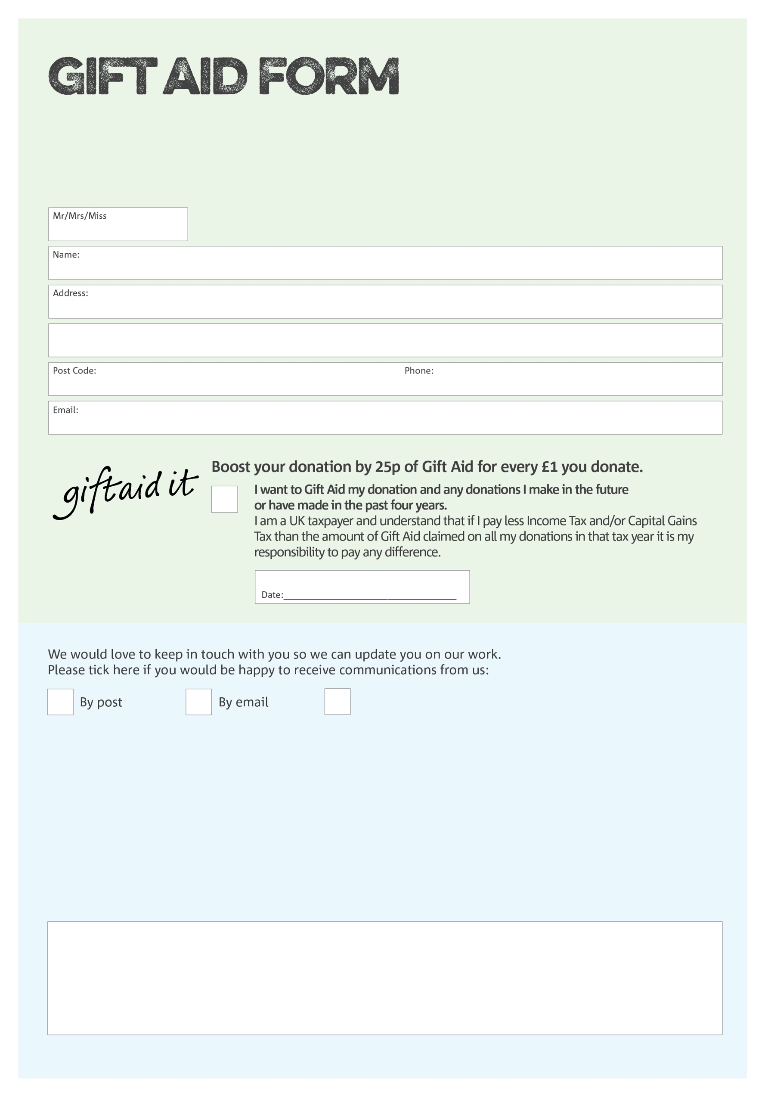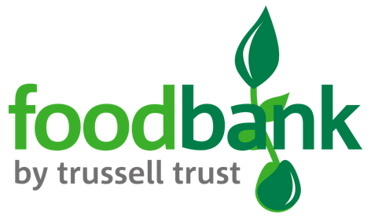

By filling in this form Bognor Foodbank will receive an extra 25p for every £1 you give at no extra cost to you. Thank you!

**Data protection**

*Bognor Foodbank is committed to protecting your privacy and will process your personal data in accordance with current Data Protection legislation. Bognor Foodbank collects information to keep in touch with you and supply you with information relating to our work. A full data privacy statement for financial donors is available from the foodbank on request.*

You can change your preferences any time by contacting us on 01243 866952 or emailing us at bognorfb@hotmail.co.uk

I do not wish to receive future communications from Bognor Foodbank

We would love to know why you have chosen to donate to Bognor Foodbank. If you would like to share your motivation let us know below:

Charity Number 1148187 Registered in 2012