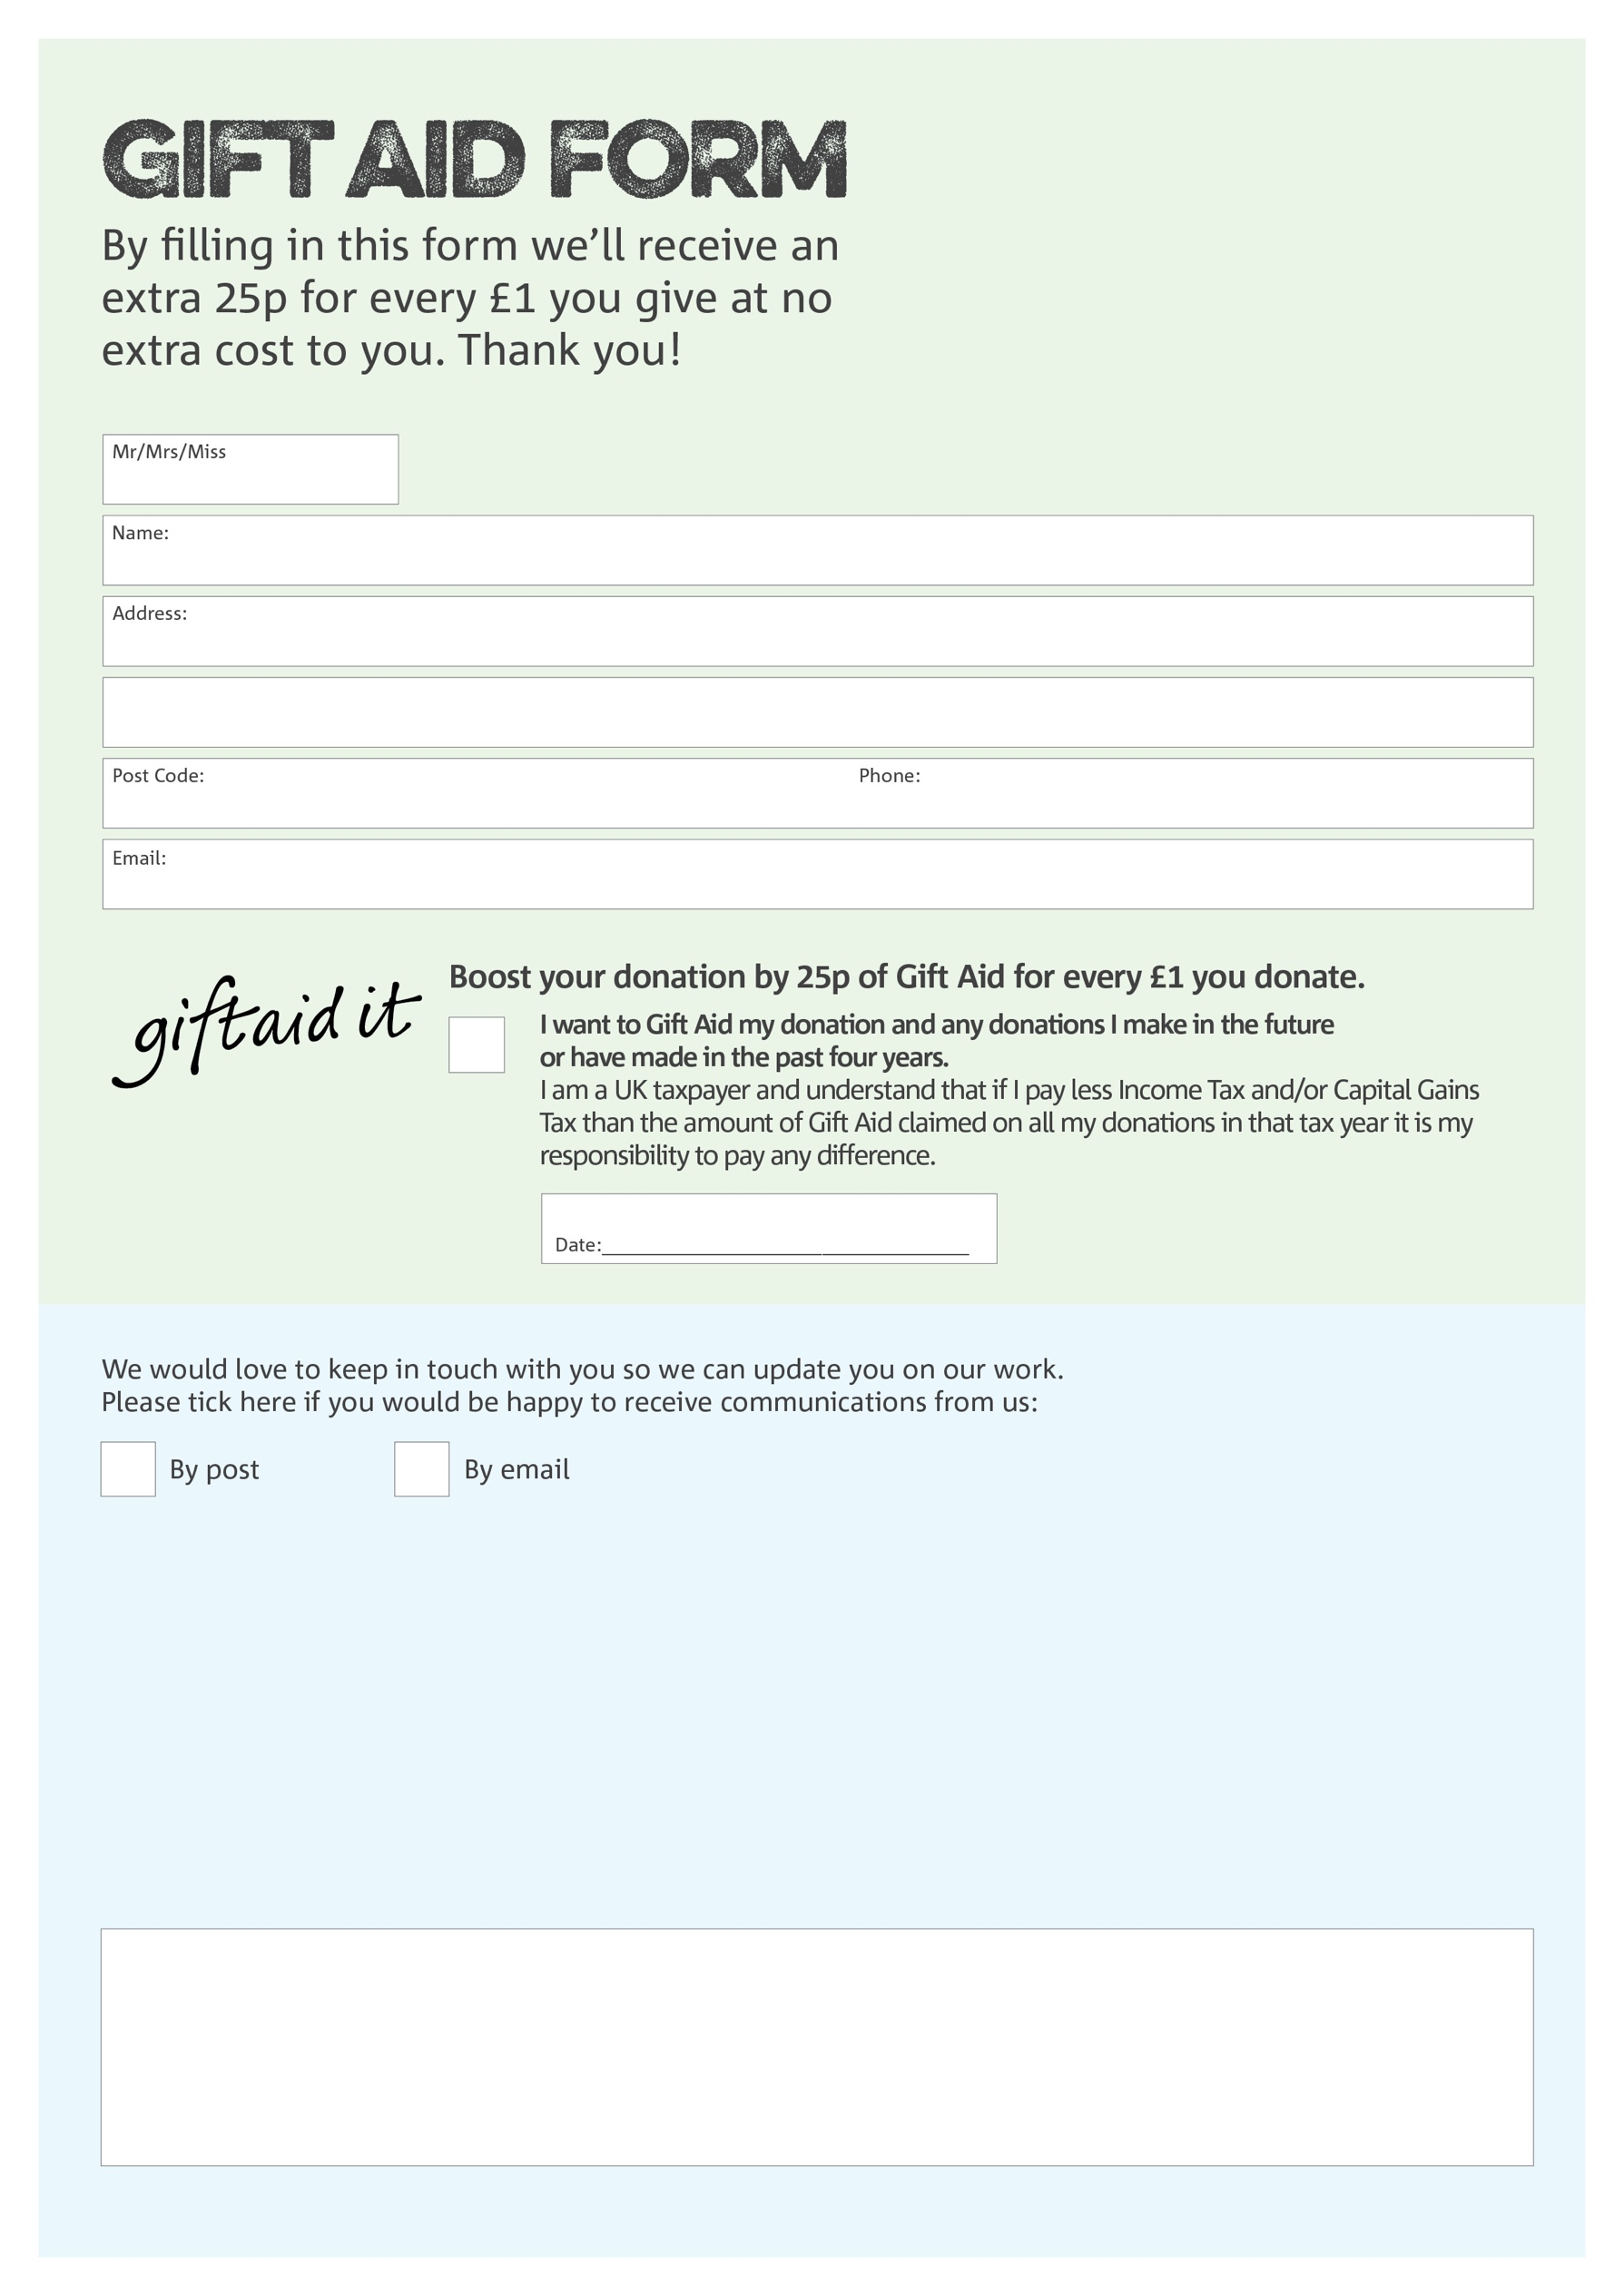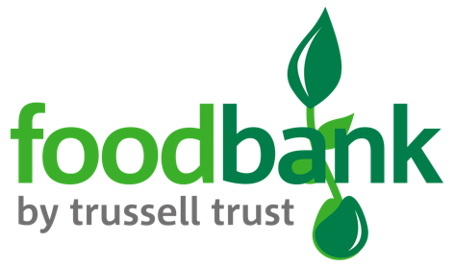

**Data protection**

Bognor Regis Foodbank is committed to protecting your privacy and will process your personal data in accordance with the Data Protection Act 1998. Bognor Regis Foodbank collects information to keep in touch with you and supply you with information relating to our work. Bognor Regis Foodbank will never sell or pass your details to anyone who isn’t directly working on our behalf.

You can change your preferences any time by contacting us on 01243 886952 or emailing us at bognorfb@hotmail.co.uk

We would love to know why you have chosen to donate to Bognor Regis Foodbank. If you would like to share your motivation let us know below:

Charity Number 1148187. Registered in 2012