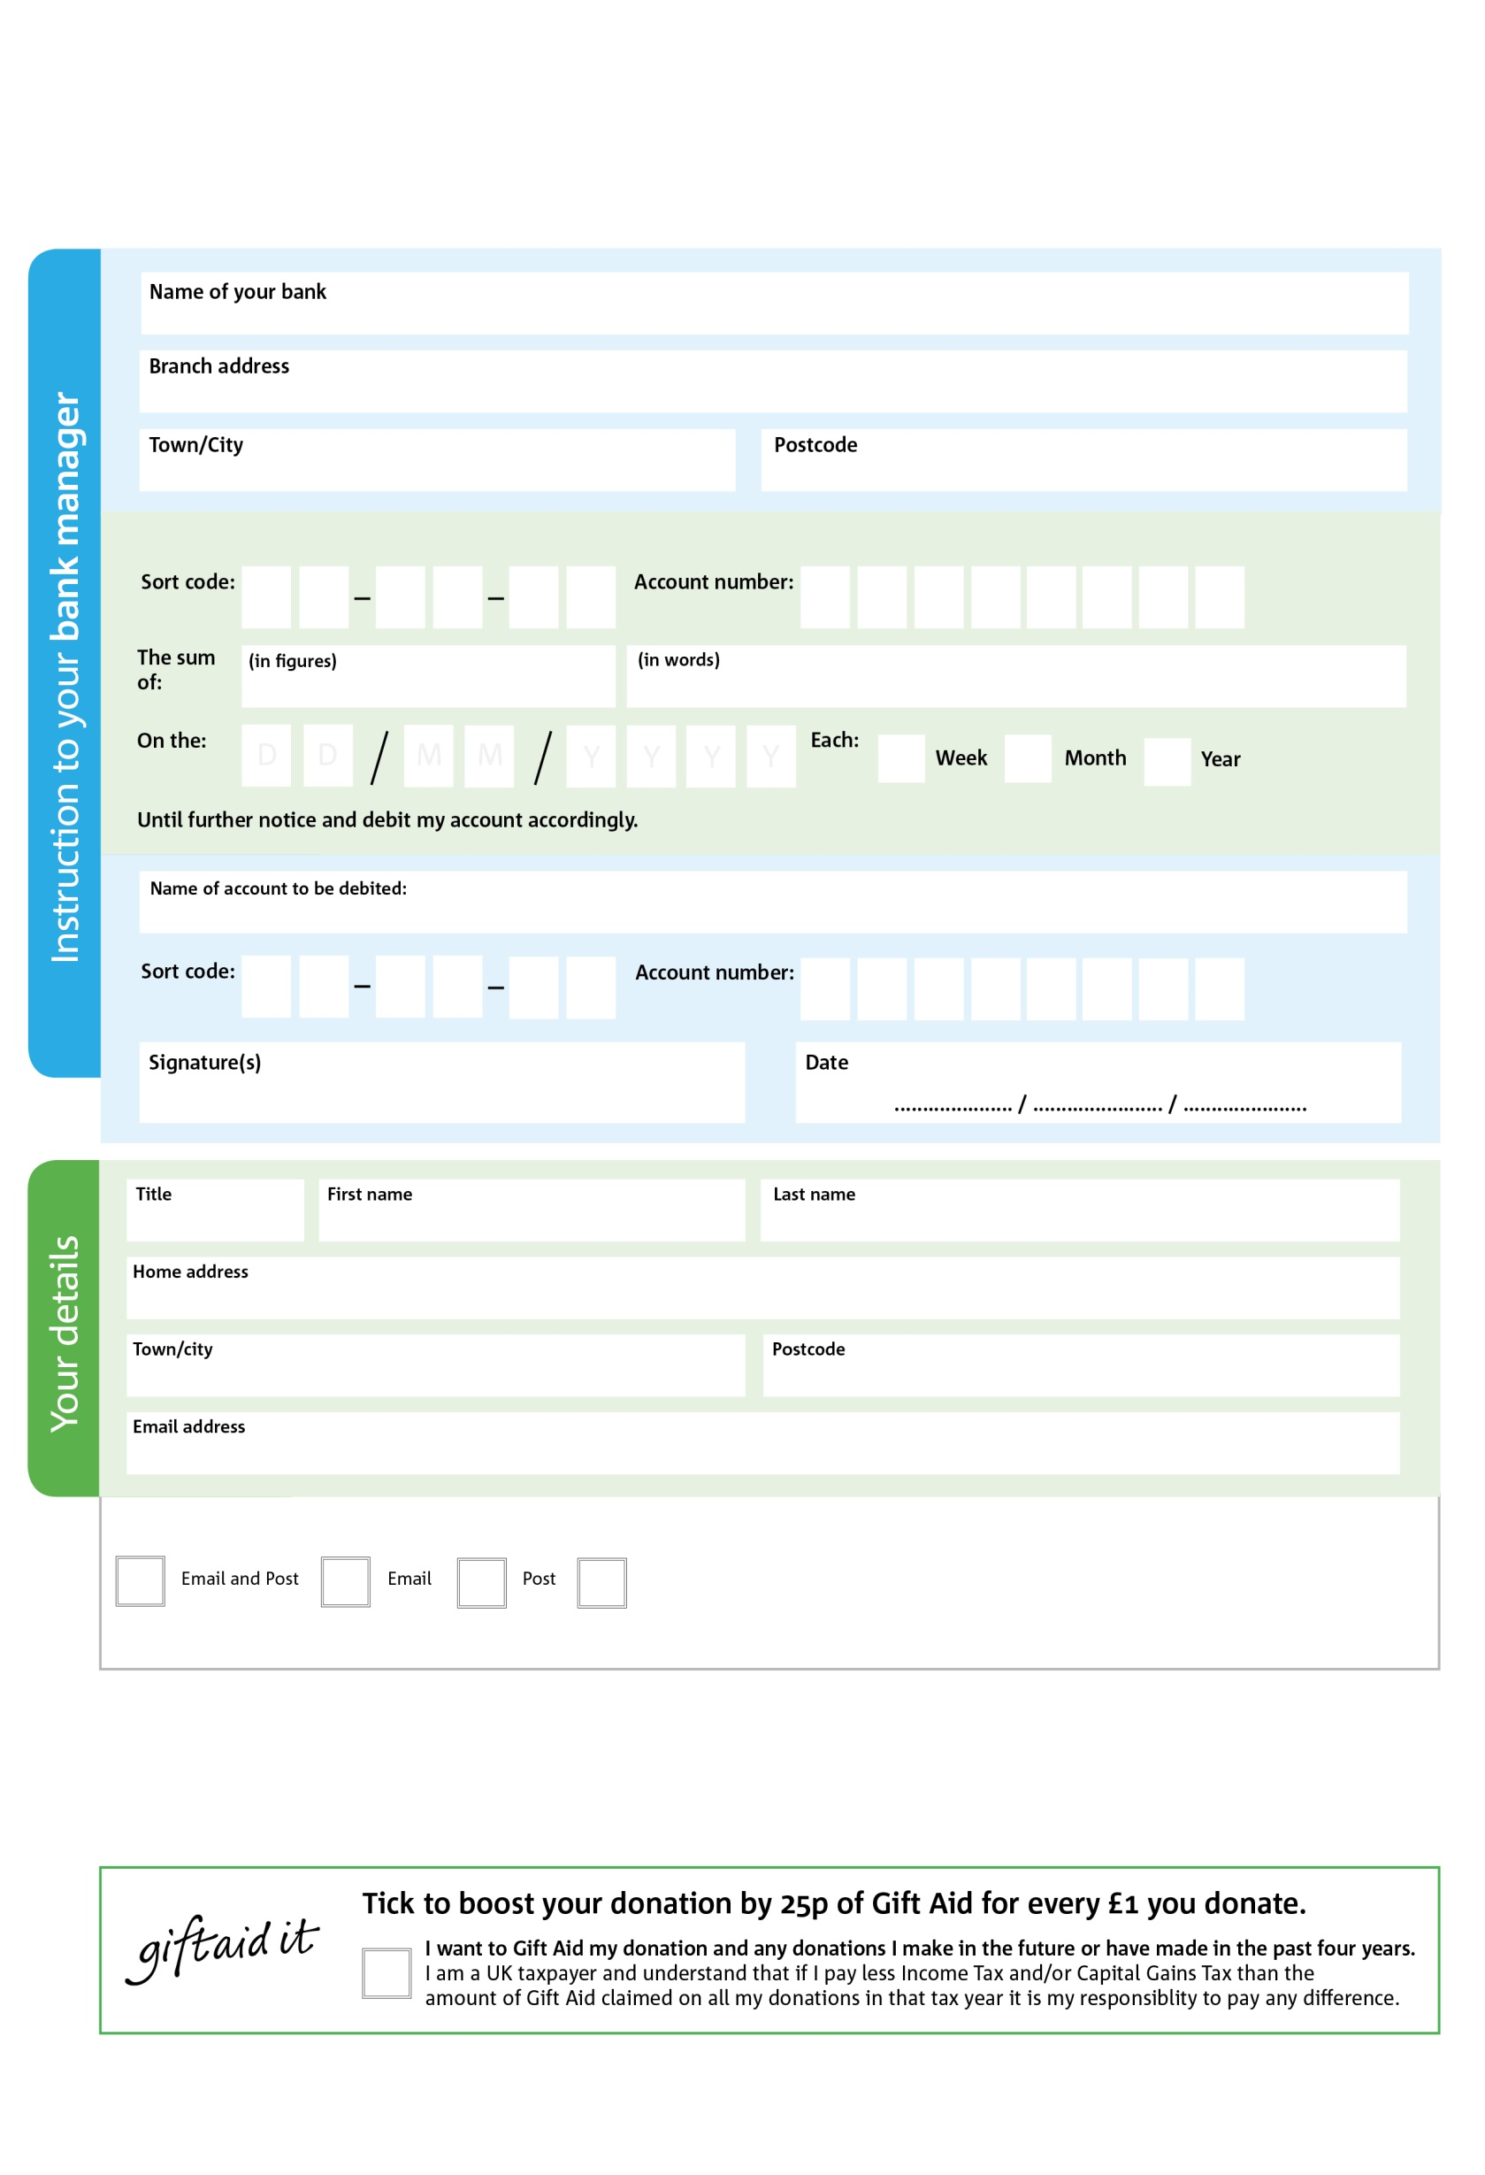

POSTAL ADDRESS: Bognor Foodbank, Argyle Road, Bognor Regis, West Sussex, PO21 1DY

Reg. Charity No: 1148187 Reg. in England & Wales Wales

5

V

2

V

6

V

11

V

6

V

1

V

3

V

9

V

**Please pass this form onto the foodbank, using the foodbank’s address at the bottom, who will save a copy for their records.   
They will then send it onto your named bank or building society.**

2

6

0

2

0

20

We would love to keep you up to date with information about Bognor Foodbank. Please tick your preference:

You can change your preferences any time by contacting us on 01243 868800 or emailing us at bognorfb@hotmail.co.uk

I do not wish to receive future communications from Bognor Foodbank

Please pay Bognor Foodbank,

**Data protection**

*Bognor Foodbank is committed to protecting your privacy and will process your personal data in accordance with current Data Protection legislation. Bognor Foodbank collects information to keep in touch with you and supply you with information relating to our work. A full data privacy statement for financial donors is available from the foodbank on request.*

**Standing Order Mandate**

**bognorregis.foodbank.org.uk**

You can change your preferences any time by contacting us on XXXXXXXXXXX or emailing us at XXXX@XXXXXXXXXX.foodbank.org.uk

I do not wish to receive future communications from XXXXXX Foodbank