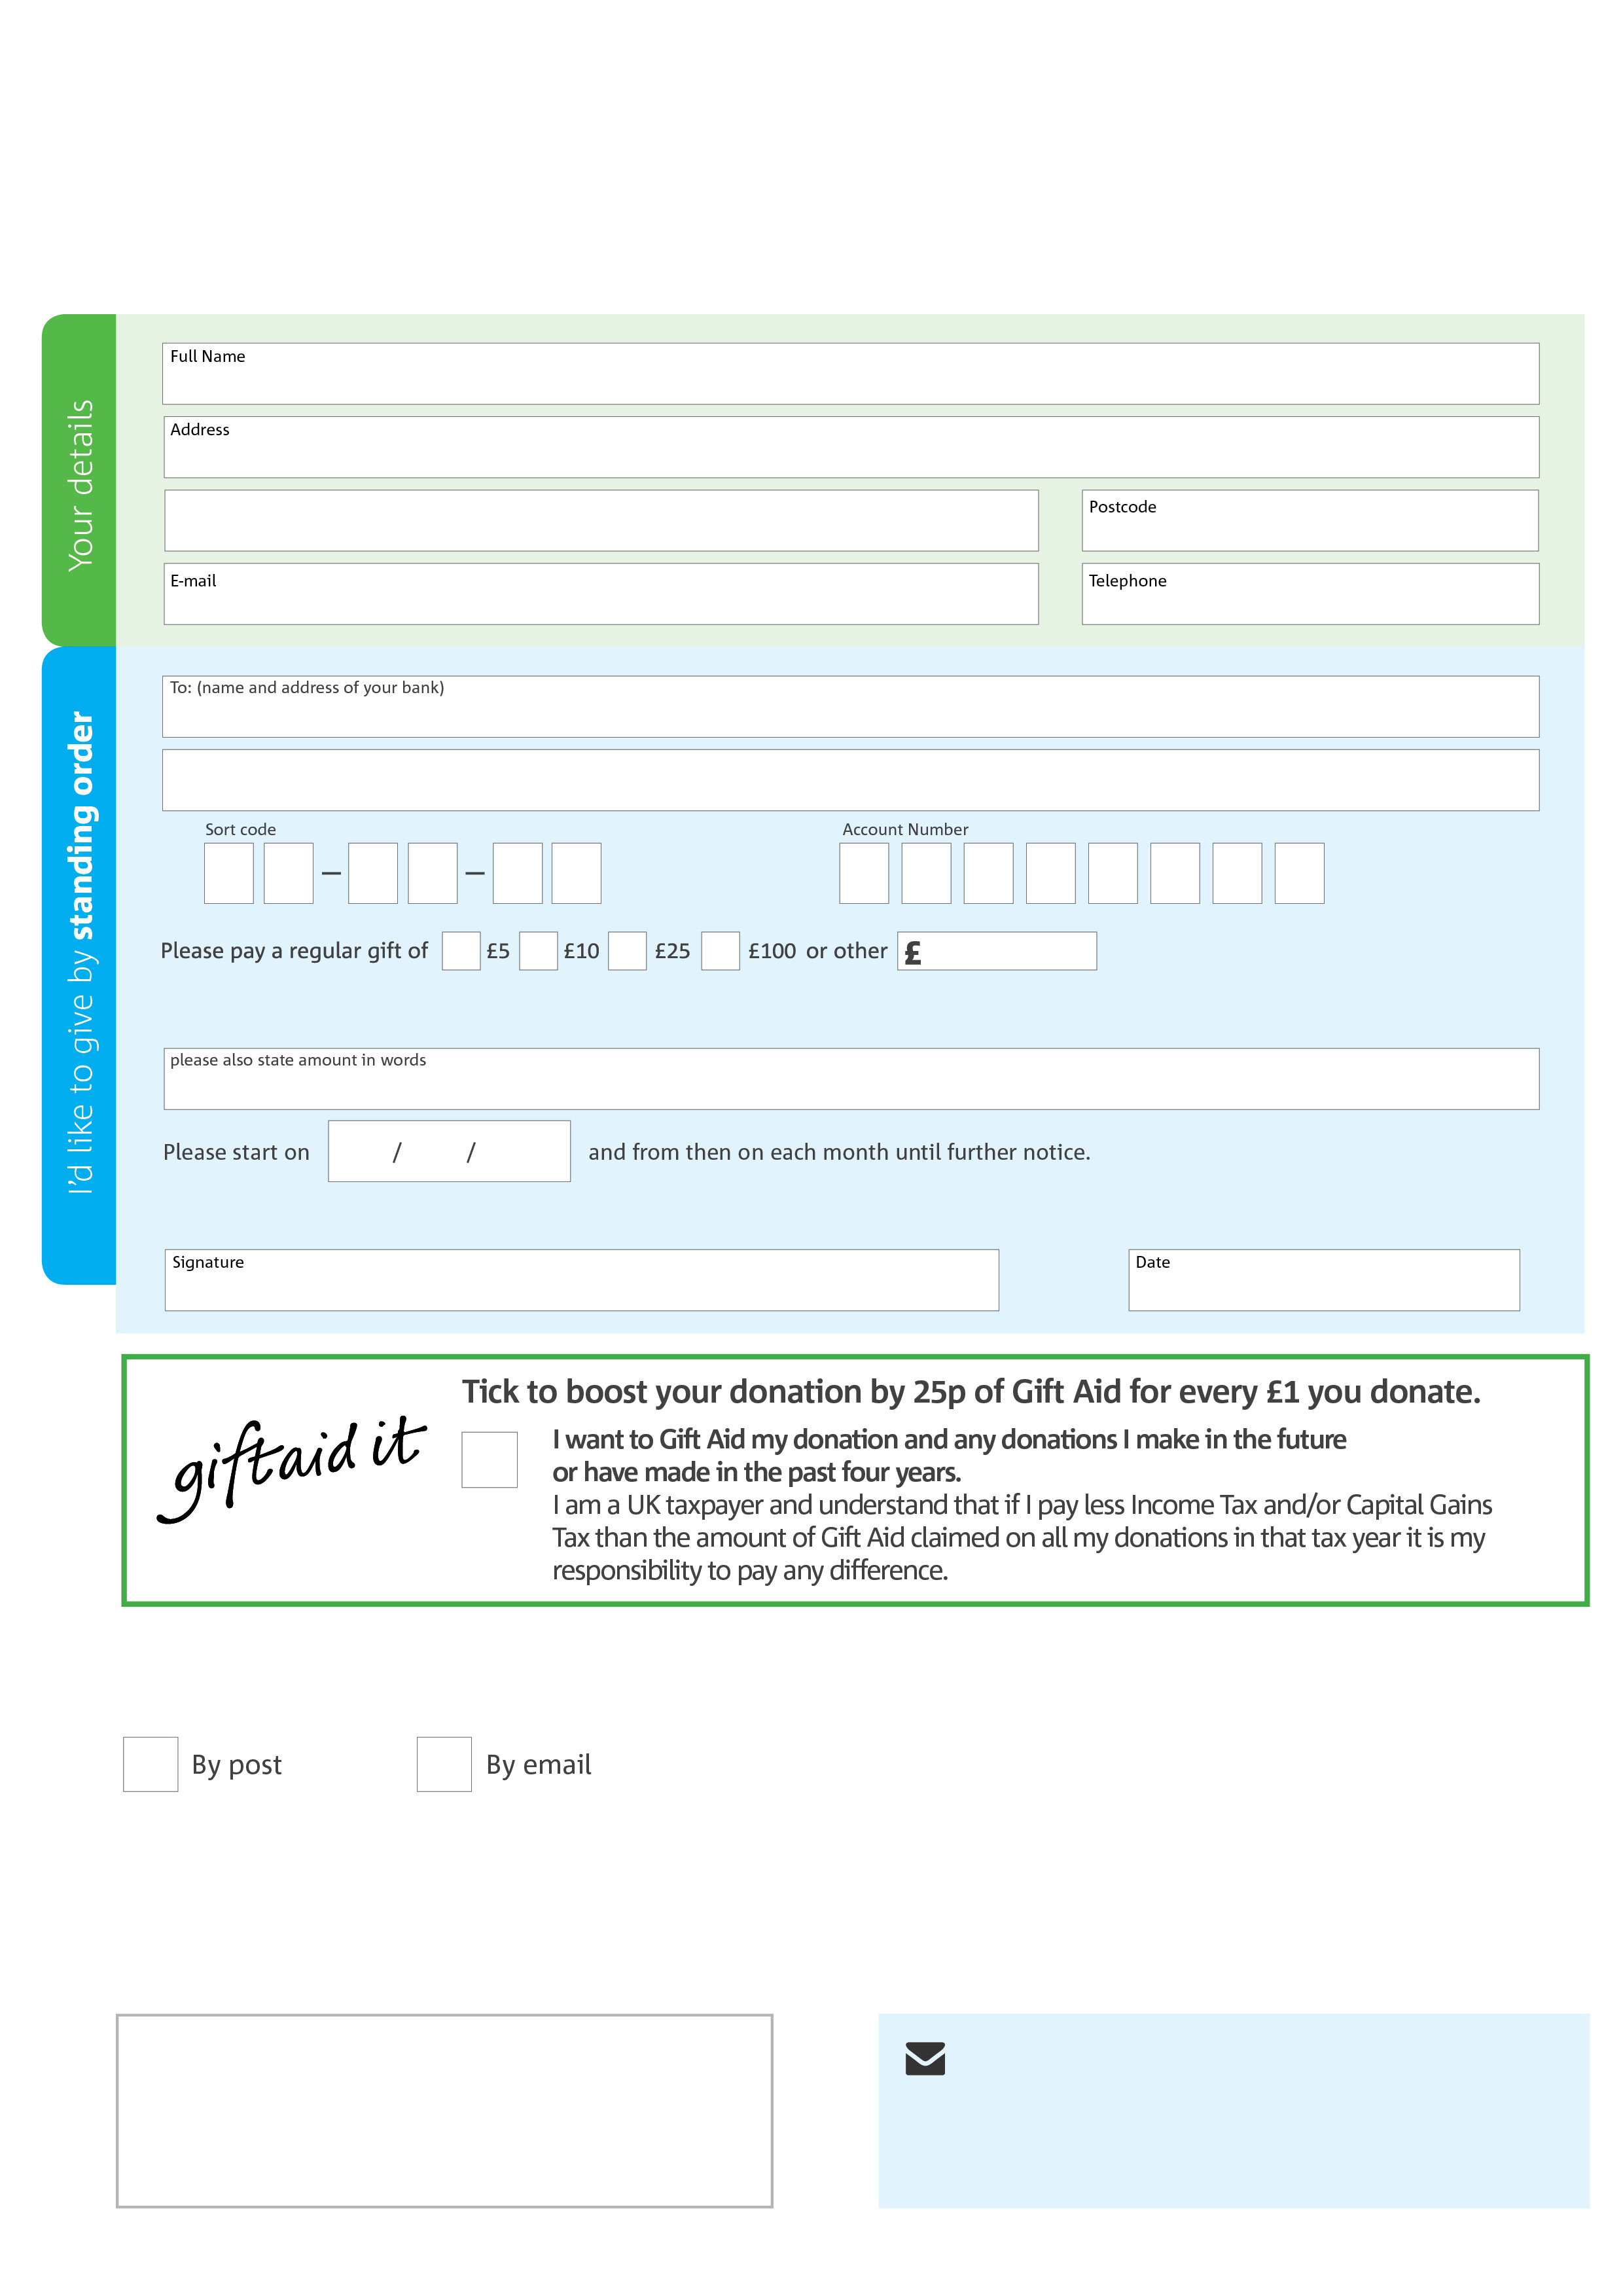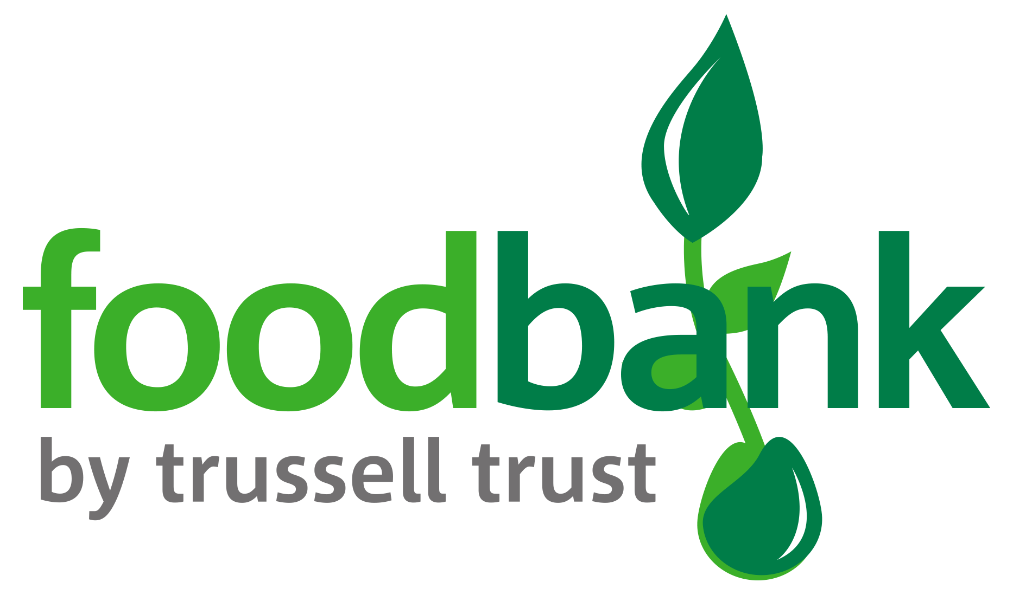­

**Data protection**

Bognor Regis Foodbank is committed to protecting your privacy and will process your personal data in accordance with the Data Protection Act 1998. Bognor Foodbank collects information to keep in touch with you and supply you with information relating to our work. Bognor Foodbank will never sell or pass your details to anyone who isn’t directly working on our behalf.

**We would love to keep in touch with you so we can update you on our work. You can change your preferences any time by contacting us on 01243 866952 or emailing us at bognorfb@hotmail.co.uk**

**Please tick here if you would be happy to receive communications from us:**

**Bognor Regis Foodbank’s bank details:**

**Barclays Bank, High Street, Bognor Regis, W Sussex**

Sort Code : 20-20-62

Account No : 93161625

**Please send your completed form to**

Foodbank Administrator

c/o Opengate Church, 73 Victoria Drive, Bognor Regis

W Sussex PO21 2TD

This cancels any previous standing order instructions to Bognor Foodbank

To Bognor Foodbank each month,

bognor regis.foodbank.org.uk

Reg. Charity No: 1148187 | Reg. in England & Wales